# Request Record – Job Manager view

## Request Info Panel

Below you will find screenshots of the Request Record panels with the default fields. Most of the fields are simply text fields, some are dropdown value fields and Field Templates.

Please advise if any field names need to be relabeled, removed or if a field needs to be added to further describe the request/order that is being placed for the specific property. The fields you see with a red * indicate that field is a required field and will need to be completed prior to moving on to the next page. Please advise if any additional fields need to be set as a required field and/or if any current required field does not need this requirement. The items highlighted in the first screenshot are dropdown value fields and/or Field Template(s), you will find additional information/description below the screenshot.

1. Request Purpose field listed below with the default dropdown values. Please review and advise of any changes:

1. Ordering Choices field listed below with the default dropdown values. Please review and advise of any changes:

1. Loan Type field listed below with the default dropdown values. Please review and advise of any changes:

1. Payment Method field below with the default dropdown values. This would be if you require Loan Officer to advise the payment method.

1. Intended Use of Request: In addition to this field allowing for “free type” this is what we call a *Field Template* and you are able to create multiple templates (you provide the wording and template name and we will enter on the back end of YouConnect). This will help to cut down on data entry and works well when repeated information needs to be populated for each property. The template choices you see below in our default are just examples and can be used or removed (FYI your bank name would be entered in the template below where it says Bank Name):

1. Intended User of Request is also a *Field Template:*

**Special Note\***

**Date Needed –** This is the date the Loan Officer is asking to have the report returned to them. One option is to relabel this to **Dated Needed (Report & Review)** if youwant to make itclear to yourlenders this would be the date for both the Report and Review to be completed.

**\*Prior Appraisal Date and Prior Appraised Value –** The Loan Officer’s do not fill these fields, however if there was a previous appraisal done on a property, the next time a new order is submitted against the property the Prior Appraised Value & Date will automatically populate. We recommend you do not remove this from the Request Record.

**Billing/Branch Code (Also known as Cost Center) & GL Acct** fields are connected to a Loan Officer’s user profile. When a Loan Officer is selected on a Request, the Billing/Branch Code & GL Acct # will automatically populate (only if the user record has these fields populated – when we ingest your users into YouConnect you will be given the opportunity to provide this information or we can explain to the Loan officers during their training they will need to update their profile to add in this information).

**Lending Group –** if you use Lending Groups for Accounting purposes please provide us with your list and we will add them as selectable values. This will also be an available option to include on your user list and we will discuss further when we get to that section.

**HPML –** this is an old function and it is not normally used. We will remove unless you say otherwise.

**Request Comments-** These are the comments between the Loan Officer and the Job Manager

**Contact Access Info Panel**

This information provides the necessary information to the appraiser to be able to gain access to complete their work. Please review the fields and advise of any changes. The items highlighted in the first screenshot below are dropdown value fields, you will find additional information/description under the screenshot.

1. Marketing Status field listed below with the default dropdown values. Please review and advise of any changes:

1. Contact Type field listed below with the default dropdown values. Please review and advise if any changes:

Environmental Info Bid/Engagement Panel (only applies if doing Environmental orders) - Job Manager View

Through the fields in this panel, you can provide additional information to your Environmental vendors related to the scope of the assignment. *It is recommended to fill out all applicable fields before any vendors are solicited for bidding*.

Please advise if any of the dropdowns or checkboxes need to be adjusted, and if any fields need to be added, removed, relabeled or set as required.

**Dropdown fields specific to this option:**

**Report Type** (for Env orders)-Please supply us with your Report Type selections for an environmental order.

**Intended Use** (for Env order): Please see screenshot below with default dropdown values. Please review and advise of any changes:

## Bid/Engagement Panel for Appraisals– Job Manager View

Through the fields in this panel, you can provide additional information to your vendors related to the scope of the assignment. *It is recommended to fill out all applicable fields before any vendors are solicited for bidding*.

There are 4 panel configuration options that you can choose from, each with a different layout and Value Scenario fields. Please choose the desired configuration option, advise if any of the dropdowns or checkboxes need to be adjusted, and if any fields need to be added, removed, relabeled or set as required.

At a later stage in the configuration process, you’ll also have the option to choose if Loan Officers can enter data within the Value Scenario fields at the time of Request submission.

**Using the arrows, please expand each option below to find additional information.**   
  
*Note: Options 1 and 2 are most commonly used, but if you have the business need for a panel that uses checkboxes or dropdowns (no columns), please see Options 3 and 4.*

### OPTION 1

**3 column option** with “Inspection Requirements” and “Approach to Value” underneath.

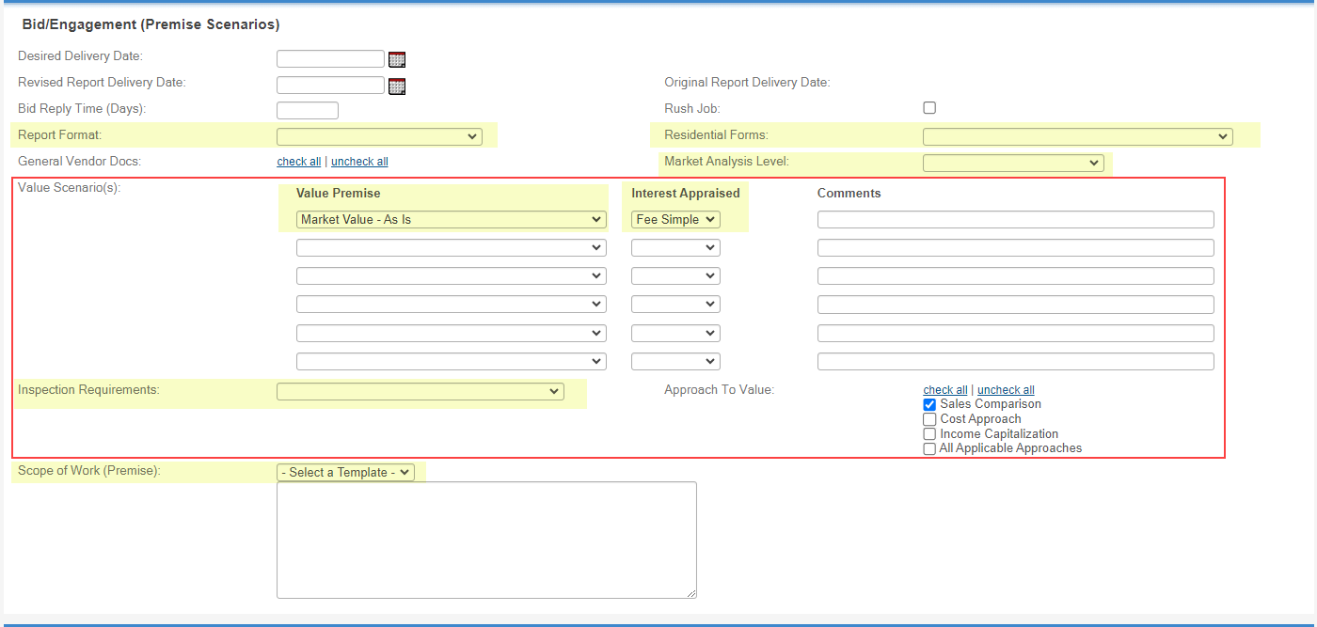

**Dropdown fields specific to this option:**

* **Value Premise** and **Interest Appraised** fields listed below with the default dropdown values. Please review and advise of any changes:

* **Inspection Requirement** field listed below with the default dropdown values. Please review and advise of any changes:

### OPTION 2

**4 column option** with “Inspection Requirements” and “Approach to Value” underneath, and “Value Qualifier” in a separate column.

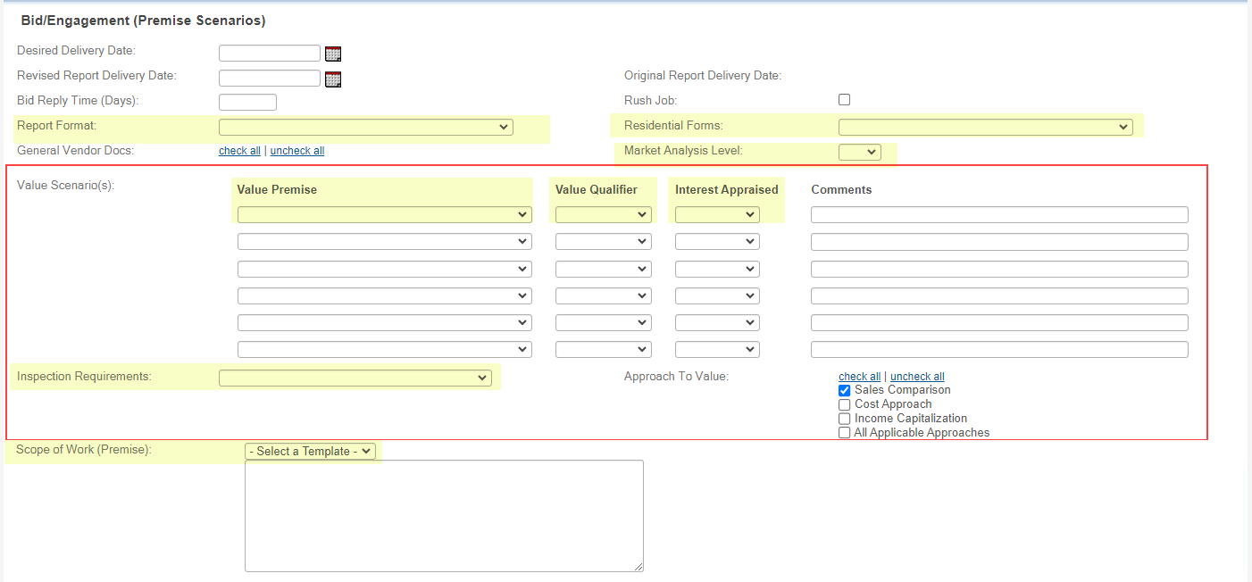

**Dropdown fields specific to this option:**

* **Value Premise**, **Value Qualifier** and **Interest Appraised** fields listed below with the default dropdown values. Please review and advise of any changes:  
    
  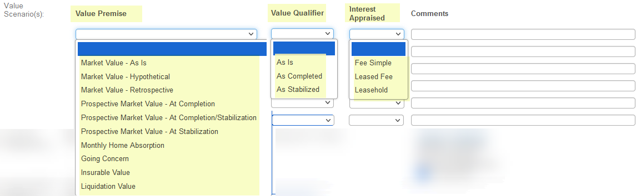
* **Inspection Requirements** field listed below with the default dropdown values. Please review and advise of any changes:  
    
  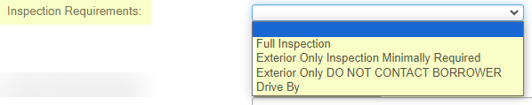

### OPTION 3

**Checkboxes Option.**

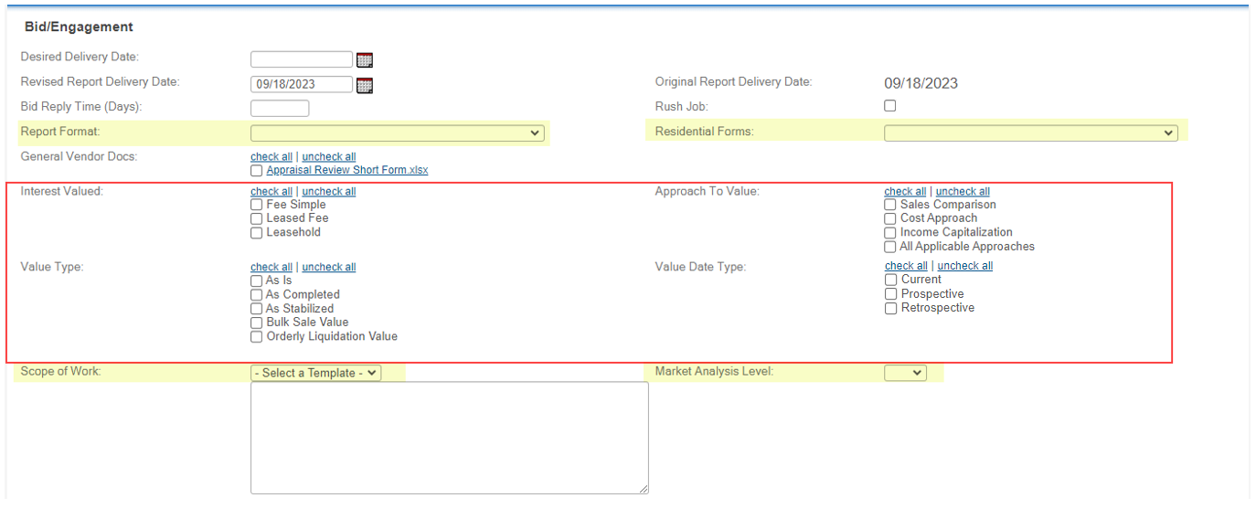

### OPTION 4

**Dropdowns option with a dedicated field for “If Leased Fee” (Field Template).**

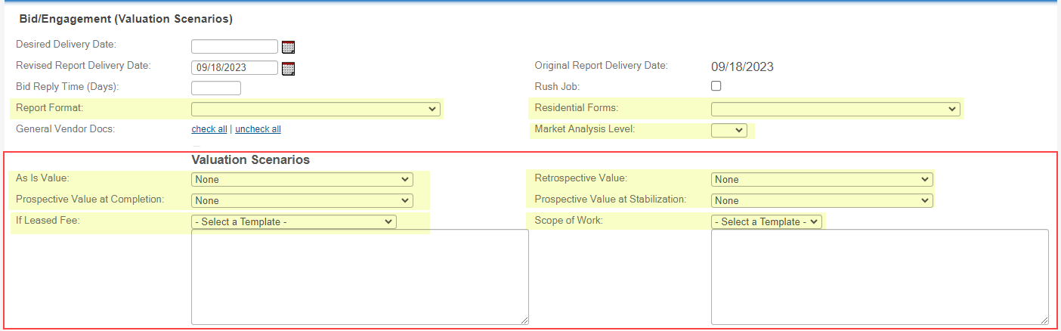

**Dropdown fields specific to this option:**

* **As is Value, Retrospective Value, Prospective Value at Completion** and **Prospective Value at Stabilization** fields share the same default dropdown values list. Please review and advise of any changes:  
    
  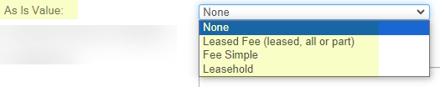  
    
  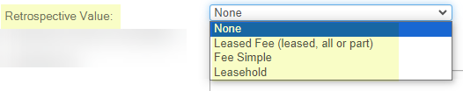  
    
  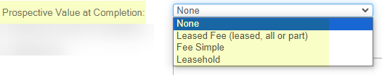  
    
  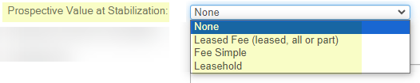
* **If Leased Fee** – Field Template (see definition of “Field Templates” above).

### Additional Information on the fields that are applicable to all 4 configuration options (to assist you with the decision-making process)

* **Desired Delivery Date** – specifies the desired date by which the assignment should be completed.   
  *This helps the vendors understand the urgency of the assignment before placing their bids (where applicable).*
* **Revised Report Delivery Date** – allows a Job Manager to grant an extension to the engaged vendor.   
  *A report submitted on or before that date will not be counted as “late”.*
* ***Original Report Delivery Date*** *– populates automatically with the original report delivery date (before any potential changes are made).*
* **Bid Reply Time (Days**) – the number of days that solicited vendors have to submit their bids.   
  *Note: Bids can be submitted by solicited vendors up until a vendor has been formally engaged.*
* **Rush Job** – a checkbox field which simply indicates if this is a “Rush Job”.
* **General Vendor Docs** – allows a Job Manager to select the general docs that will become visible to the vendors upon solicitation. *The desired list of documents can be uploaded and updated at any time (during Onboarding and/or post Go-live).*
* **Scope of Work** - Field Template (see definition of “Field Templates” above).
* **Residential Forms** field listed below with the default dropdown values. Please review and advise of any changes:  
    
  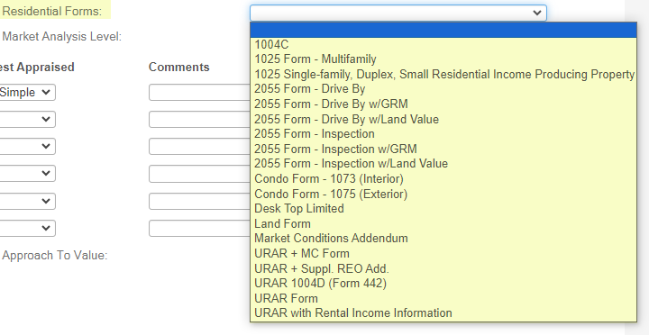
* **Report Format** field listed below with the default dropdown values. Please review and advise of any changes:  
    
  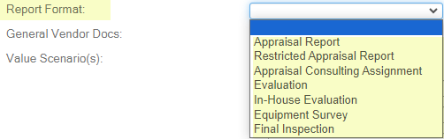
* **Market Analysis Level** field listed below with the default dropdown values. Please review and advise of any changes:  
    
  